**OBJECT-ORIENTED PROGRAMMING**

|  |  |
| --- | --- |
| Lab 1 | |
| **Topic** | Pointers, arrays, and functions |
| **Objective** | To learn the usage of pointers and arrays and Functions |

## Task 1:

Write a program that declares 3 variable and print their addresses.

1. Print the address and value of a variable using a dynamic variable.
2. Updates the value of a variable using a dynamic variable.
3. Print the updated value.
4. find the **sum, average** of **three** numbers and by using **dynamic** variables.
5. Find the min out of these 3 dynamic variables.

**Task 2:** Write a C++ Program to

1. insert and display data in the array by using a pointer.

OUTPUT:

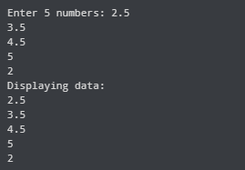

1. print the sum and average of the array’s elements

**Task 3:**

Write a program in C++ that reads data from a file (ask the user to enter the file name) into the dynamic array.

Write a function that will keep only single-digit numbers from data and shrink the size of the array using functions.

**Example:**

**Data:** 2 3 15 1 82 8 9 10 21 55 12 14 16 18 7 4 55 6

**single-digit:** 2 3 1 8 9 7 4 6

**Task 4:**

Write a program in C++ that reads text (character data) from a file (user-defined file name) to a dynamic array. Check whether the character is a vowel (a, e, i, o, u) or not. If a vowel, keep it from the text and shrink the size of the text using functions.

Example:

Original text: Abcdefghijklmnopqrstuvwae

Modified text: aeiouae